Software Course Design Report

Title of the work: Inventory Management System



Major： | SOFTWERE ENGINEERING
Class： | 2018
Name： | MD RUBAYET AFSAN
Student number： | 189076015
Instructor： | 陶 陶

School of computer science and technology
December 12, 2020

Contents
1/ Abstract……………………………………………………………………….
2/Introduction…………………………………………………………
3/Theoretical Background………………………………..
4/Problem Definition………………………………
5/Purpose and scope……………………….
6/Technologies used……………….
7/Introduction to developments tools………………………………
8/Feasibility analysis…………………………………….
9/Methodology used for testing………………….
10/user interface………………………………
11/pictures of codes…………
12/ conclusion…………

Abstract:

Inventory management is a challenging problem area in supply chain management. Companies need to have inventories in warehouses in order to fulfil customer demand, meanwhile these inventories have holding costs and this is frozen fund that can be lost. Therefore, the task of inventory management is to find the quantity of inventories that will fulfil the demand, avoiding overstocks. This paper presents a case study for the steel manufacturing industry (Small Scale Industry) on inventory management. The relationship between the inventory management and company performance was determined based on inventory days and return on asset (ROA) analysis. The research found that company X had a few inventory problems such as unorganized inventory arrangement, large amount of inventory days / no cycle counting and no accurate records balance due to unskilled workers. The study also proved that there was a significant relationship between return on asset (ROA) and inventory days. This paper also provides recommendation to the company and for further research.

INTRODUCTION
Inventory is the supply of raw materials, partially finished goods called work-in-progress and finished goods, an organization maintains to meet its operational needs. It represents a sizeable investment and a potential source of waste that needs to be carefully controlled. Inventory is defined as a stock of goods that is maintained by a business in anticipation of some future demand. The quantity to which inventory must fall in order to signal that an order
must be placed to replenish an item. Using an extension of a standard inventory-dependent demand model provide a convenient characterization of
products that require early replenishment. The optimal cycle time is largely governed by the conventional trade-off between ordering and holding costs, whereas the reorder point relates to a promotions-oriented cost-benefit
perspective. The optimal policy yields significantly higher profits than cost-based inventory policies, underscoring the importance of profit-driven inventory management. To work towards perfect order metrics, there has to be aggressive inventory management, restructuring supply chain operations, and updating standards to the perfect standard. When updating the metrics, this would include the cases shipped vs. the orders on-time delivery, data synchronization, damages and unusable products, days in supply, the ordering time cycle, and shelf level of service. Inventory problems of too great or too small quantities on hand can cause business failures. If an organization experiences stock-out of a critical inventory item, production halts could result. Inventory management indicates the broad frame work of managing inventory. The inventory management technique is more useful in determine the optimum level of inventory and finding answers to problem of safety stock and lead time. Inventory management has become highly developed to meet the rising challenges in most Corporate entities and this is in response to the fact that inventory is an asset of distinct feature.

Theoretical Background
Observation in different companies reveals that most managers don’t make attention on inventories because they are like money placed in a drawer. Assets tied up in investments are

Observation in different companies reveals that most managers don’t make attention on
inventories because they are like money placed in a drawer. Assets tied up in investments arnot produce return but they incurring a borrowing cost. They incur costs for the care of storematerial and are subject to spoilage and obsolescence.
Inventories are materials waiting for processing. Raw material inventories provide a stable source of input required for production. A large inventory requires less replenishment and may reduce ordering costs because of economies of scale. In-process inventories reduce the impacts of the variability of the production rates in a plant and protect against failures in the processes. Final goods inventories provide for better customer service.

Problems in existing system:
- High cost of inventory.
- Consistent stock outs.
- Low rate of inventory turnover.
- High amount of obsolete inventory.
- High amount of working capital.
- High cost of storage.
- Spread sheet data-entry errors.
- Lost customers.

Problem Definition
There are a number inventory management that occurs that are not due to shrinkage. Most of these problems tar based on inaccuracies that are based on poor management and record-keeping activities. Typically too much inventory can erode working capital and profits. It is important that management spends attention to supply projections, using past demand are a basis to improve upon and adjusting for identifying and quantifying less obvious patterns. Inaccurate inventory tracking can be addressed through proper use of EDI, bar-code scanning, and RFID-based solutions to reduce data entry errors. Priories of inventory needs to be established by management using an ABC analysis and proper data analysis tools Back-up and safety stock plans through contingency planning scenarios to remove uncertainties in inventory are extremely helpful tools.
Solution to these problems:
The development of the new system contains the following activities, which try to automate the entire process keeping in view of the database integration approach.
- Supply chain complexity. ...
- Inadequately and improperly trained employees. ...
- Not enough of a game plan for the future. ...
- Not Counting Inventory Often. ...
- Not Using Automation.
- Not using good vendors.
- Not having performance measurement parameters in place.

Purpose
Inventory Management must be designed to meet the dictates of market place and support the company’s Strategic Plan . The many changes in the market demand , new opportunities due to worldwide marketing , global sourcing of materials and new manufacturing technology means many companies need to change their Inventory Management approach and change the process for Inventory Control .
Inventory Management system provides information to efficiently manage the flow of materials , effectively utilize people and equipment , coordinate internal activities and communicate with customers . Inventory Management does not make decisions or manage operations, they provide the information to managers who make more accurate and timely decisions to manage their operations.
Scope
1. Determination of economic order quantity
2. Formulation of policy
3. Determination of lead time
4. Effectiveness towards running of store
5. Organisation structure
6. Determination of safety stock
7. Minimum material handling and storage cost.

Technologies used

+ Microsoft Excel
+ DB Browser for SQLite
+Python 3.5.0

* Django

*Sublime Text

Software Requirements:

*Browser (such as chrome, Mozilla, opera, internet explorer)

Introduction to development tools

Microsoft Excel: Microsoft Excel is a spread sheet program that is used to record and analyse numerical data. Think of a spread sheet as a collection of columns and rows that form a table. Alphabetical letters are usually assigned to columns and numbers are usually assigned to rows. The point where a column and a row meet is called a cell. The address of a cell is given by the letter representing the column and the number representing a row.
DB Browser for SQLite: A database is a organized collection of data. SQL, being an acronym for Structured Query Language, denotes database language used to access databases. We speak of SQL databases when we mean a database which provides an SQL interface. Such databases are called relational databases as the data is stored in a set of table between which relationships exist. A database system is a computer program which allows to create, access, edit, and manage databases. Popular ones are MySQL, MS-SQL, and Oracle DB.
Python 3.5.0: Python is a widely used general-purpose, high level programming language. It was created by Guido van Rossum in 1991 and further developed by the Python Software Foundation. It was designed with an emphasis on code readability, and its syntax allows programmers to express their concepts in fewer lines of code.
Django: Django is a high-level Python web framework that enables rapid development of secure and maintainable websites. Built by experienced
developers, Django takes care of much of the hassle of web development, so you can focus on writing your app without needing to reinvent the wheel.
Sublime Text : Sublime Text is a shareware cross-platform source code editor with a Python application programming interface (API). It natively supports many programming languages and mark up languages, and functions can be added by users with plugins, typically community-built and maintained under free-software license
Feasibility analysis
Technical feasibility:
Technical feasibility centres on the existing computer system i.e. Hardware, Software etc. Bank requires SQL database management that are all easily available with extensive development support through manuals and blogs.
Economical feasibility:
Economical Feasibility is the most frequently used method for evaluating the effectiveness of a candidate system. More commonly known as Cost/ Benefit analysis, the procedure is to determine the benefits and savings that are expected from the candidate system and compare them with costs. If the benefits outweigh costs, then the decision is made to design and implement the system.
10. Methodology used for testing
The completion of a system will be achieved only after it has been thoroughly tested. Though this gives a feel the project is completed, there cannot be any project without going through this stage. Hence in this stage it is decided whether the project can undergo the real time environment execution without any break downs, therefore a package can be rejected even at this stage.
10.1 Testing methods: Software testing methods are traditionally divided into black box testing and white box testing. These two approaches are used to describe the point of view that a test engineer takes when designing test cases.
- Black box testing - Black box testing treats the software as a "black box," without any knowledge of internal implementation. Black box testing methods include: equivalence partitioning, boundary value analysis, all-pairs testing, fuzz testing, model-based testing, traceability matrix, exploratory testing and specification-based testing.
- White box testing - White box testing, by contrast to black box testing, is when the tester has access to the internal data structures and algorithms (and the code that implement these). White box testing methods can also be used to evaluate the completeness of a test suite that was created with black box testing methods. This allows the software team to examine parts of a system that are rarely tested and ensures that the most important function points have been tested.
User interface
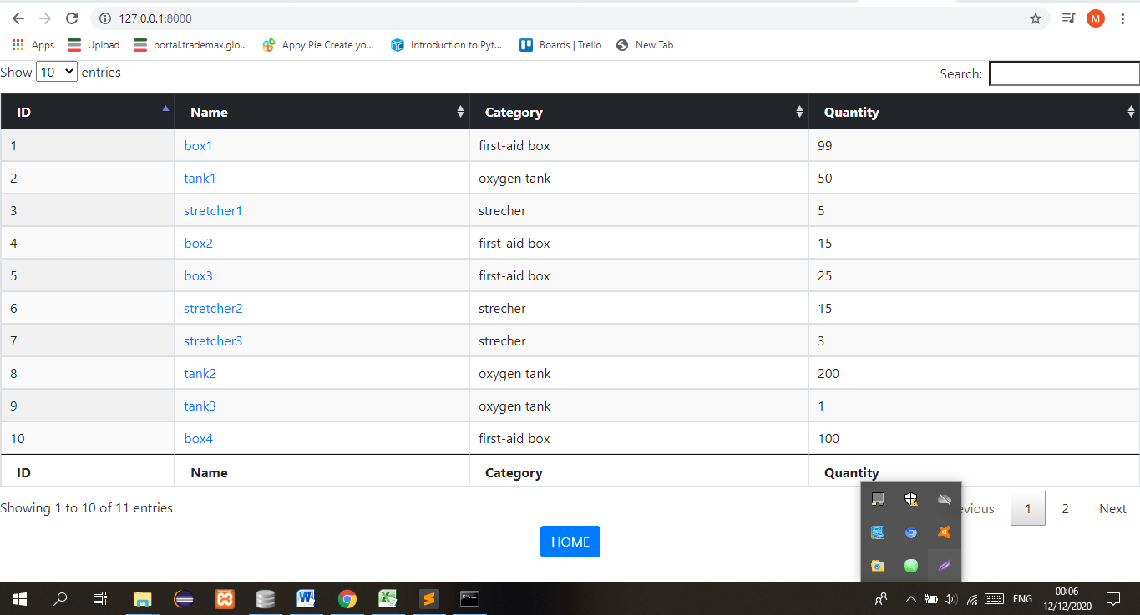

Fig: homepage

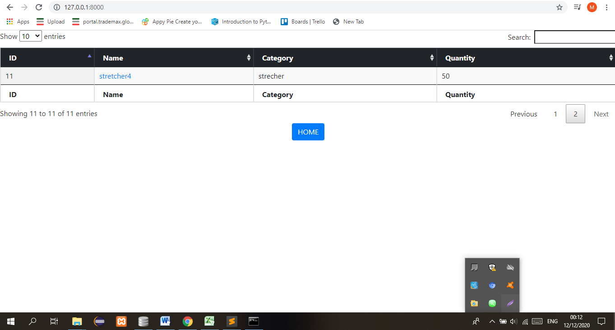
Fig: Next Page

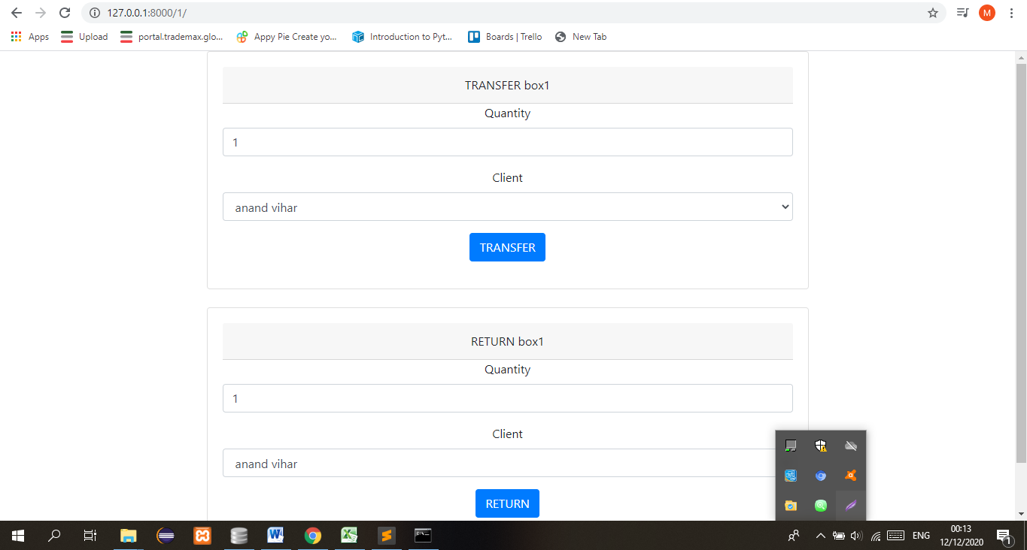
Fig: TRANSFER & RETURN
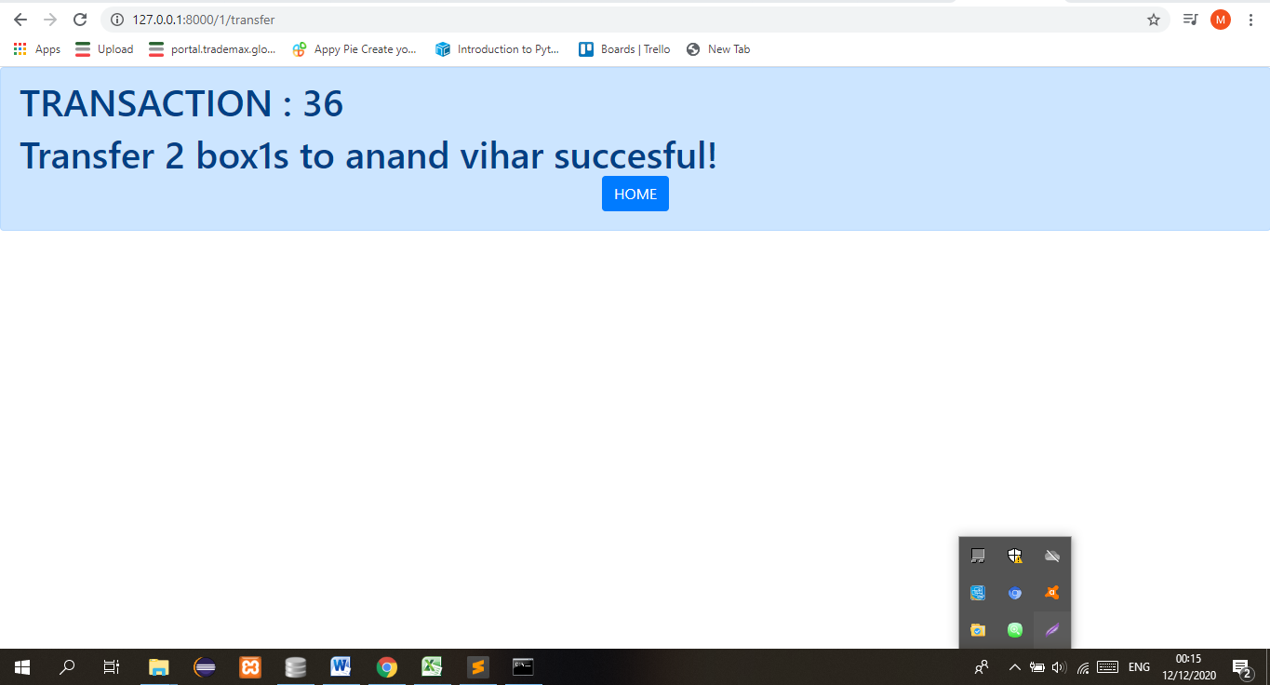

Fig: TRANSFER SUCCESFUL

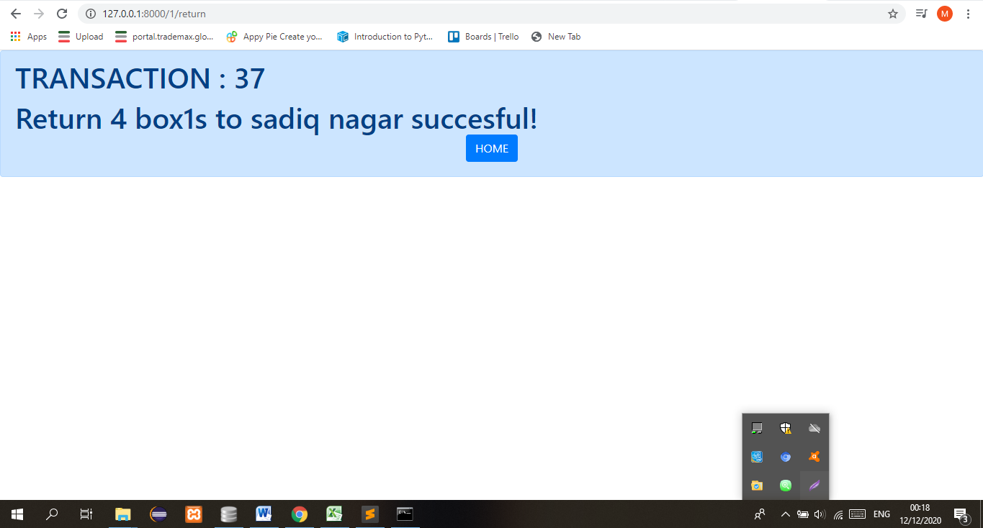
Fig: RETURN SUCCESSFUL
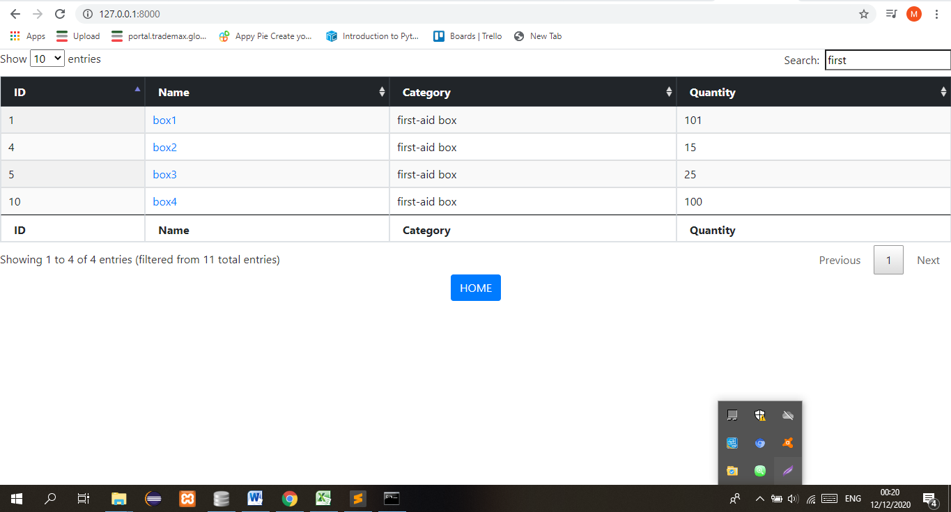
Fig: SEARCH SUCCESSFULLY
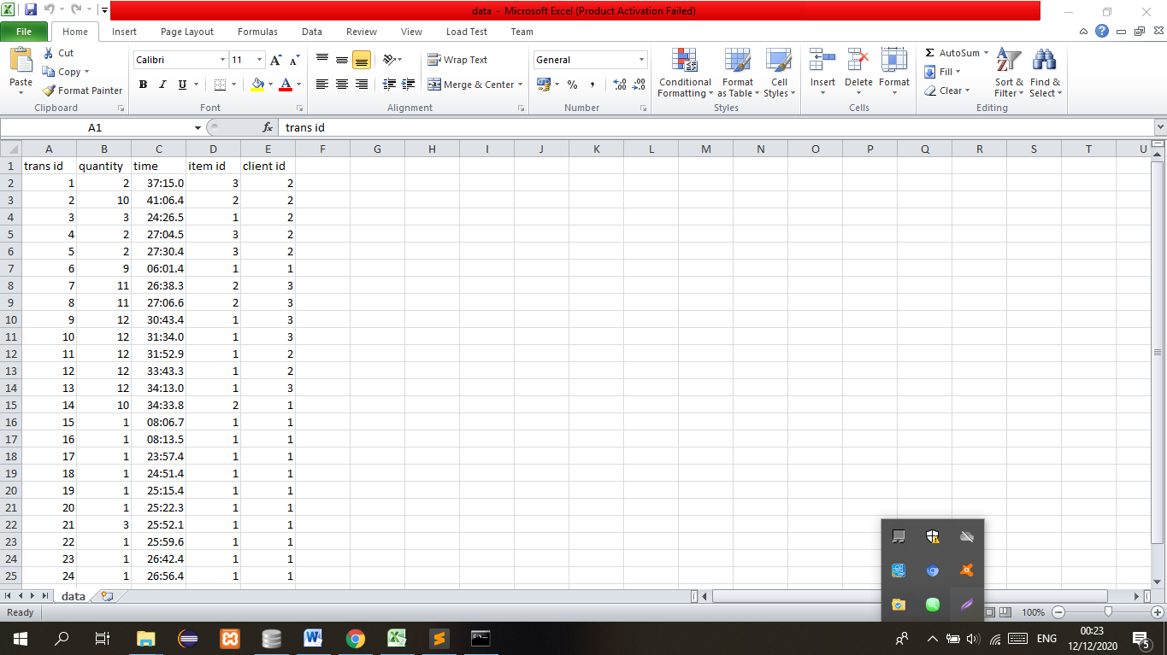
Fig: DATA TABLE

Codes
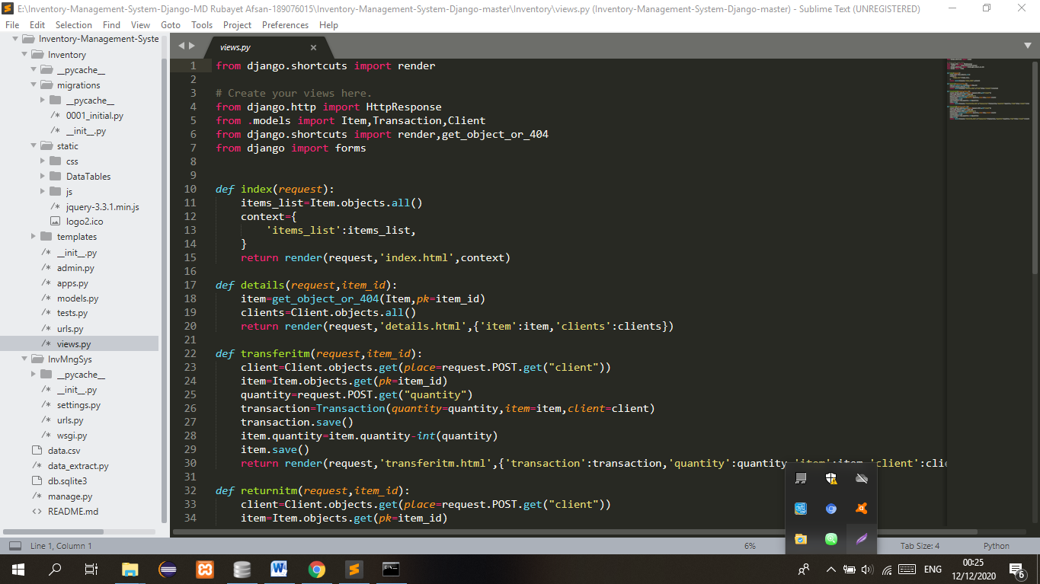

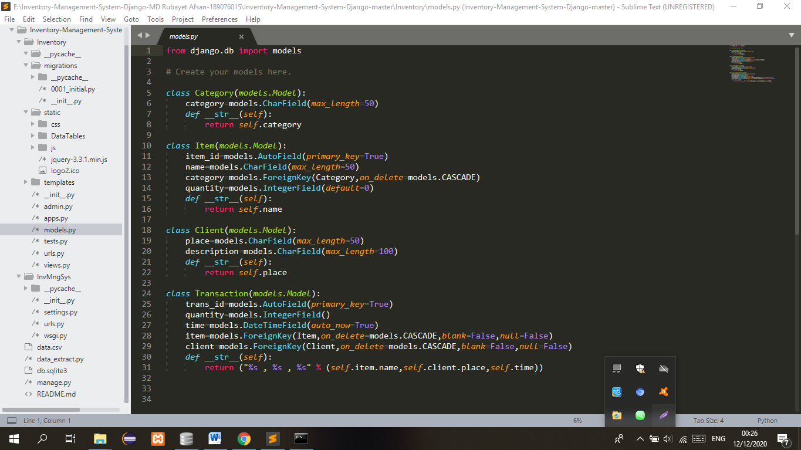
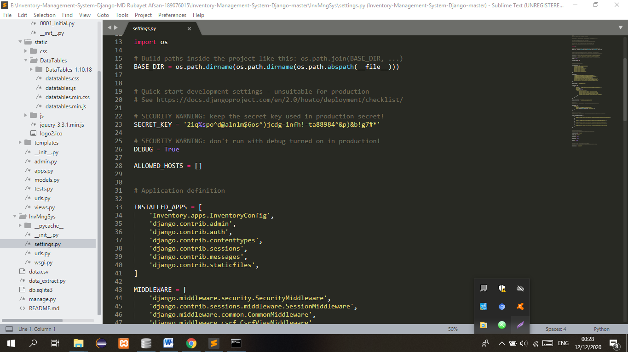
Fig: some codes from the project

Conclusion

Inventory management System has to do with keeping accurate records of goods that are ready for shipment. This often means having enough stock of goods to the inventory totals as well as subtracting the most recent shipments of finished goods to buyers. When the company has a return policy in place, there is usually a sub-category contained in the finished goods inventory to account for any returned goods that are reclassified or second grade quality. Accurately maintaining figures on the finished goods inventory makes it possible to quickly convey information to sales personnel as to what is available and ready for shipment at any given time by buyer. Inventory management is important for keeping costs down, while meeting regulation. Supply and demand is a delicate balance, and inventory management hopes to ensure that the balance is undisturbed. Highly trained Inventory management and high-quality software will help make Inventory management a success. The ROI of Inventory management will be seen in the forms of increased revenue and profits, positive employee atmosphere, and on overall increase of customer satisfaction.

